Title: **Anonymous Sudan hackers strike again. Revenge attack on Telegram!**



In revenge for the suspension of their main account, the hacking group **Anonymous Sudan** (also known as Storm-1359) has launched a distributed denial-of-service (DDoS) attack against Telegram.

"A well-known and infamous threat actor recently revealed their intent to target Telegram in an update. After Telegram decided to block their main account on the chat app, this group started the attack. according to SOCRadar.

There were roughly 120,000 users on the group's main Telegram channel.

Since its inception in January 2023, Collective Anonymous Sudan has made threats against every nation that supports Sudan. Although some security experts think Anonymous Sudan is a division of the pro-Russian terror organization Killnet.

<https://twitter.com/Cyberknow20/status/1700475977896538570>

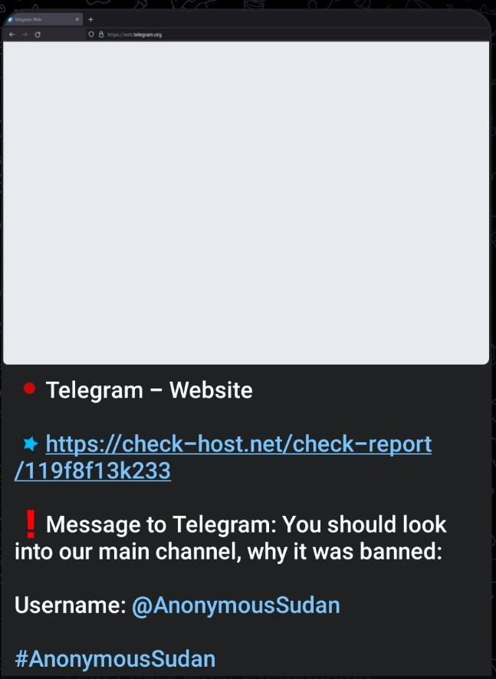

Early in June, Microsoft had significant disruptions for a number of its services, including the cloud computing platform Azure, the OneDrive file-sharing apps, and Outlook email.

The DDoS attacks that targeted the company's services were attributed to the group Anonymous Sudan.

In July, Anonymous Sudan declared that it had compromised 30 million client accounts' login information.

"We are pleased to report that we have successfully hacked Microsoft and gained access to a big database that contains more than 30 million Microsoft accounts, email addresses, and passwords. Price of the entire database: 50,000 USD, according to the statement the group posted on its Telegram channel on July 2, 2023.